Task 1: Write a Map Reduce program to filter the “NA” content.

Mapper class:

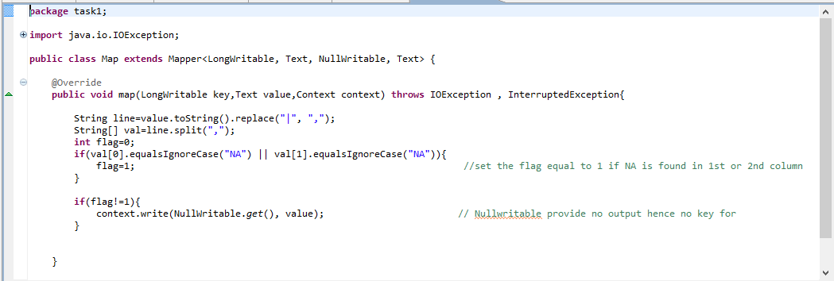

Driver class:

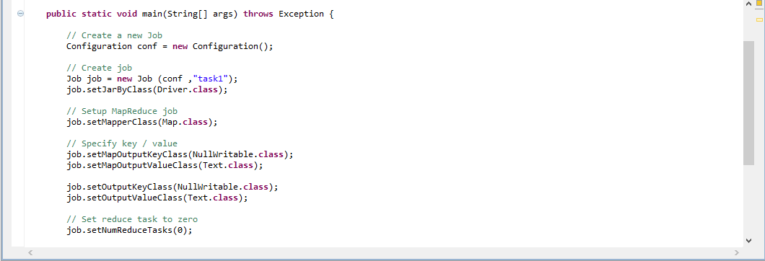

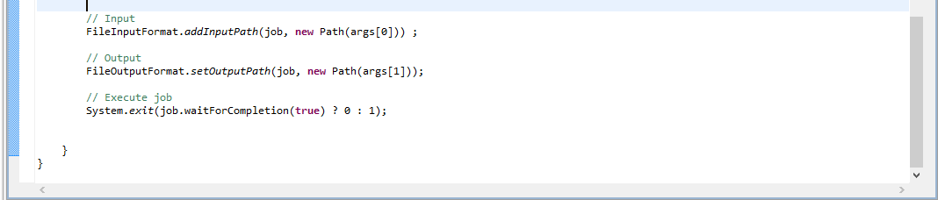

Executing jar file:

Hadoop fs jar /home/acadgild/workspace/NARecord.jar /user/acadgild/Hadoop/MROP

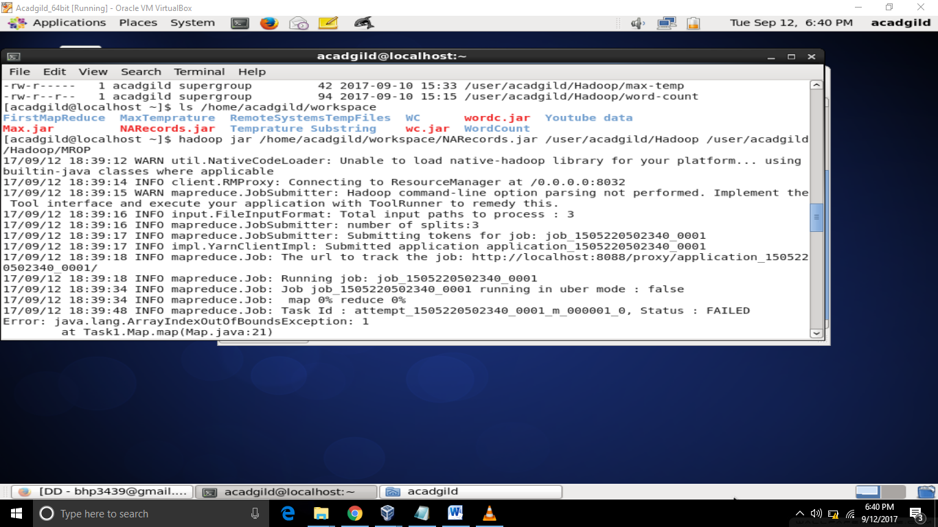

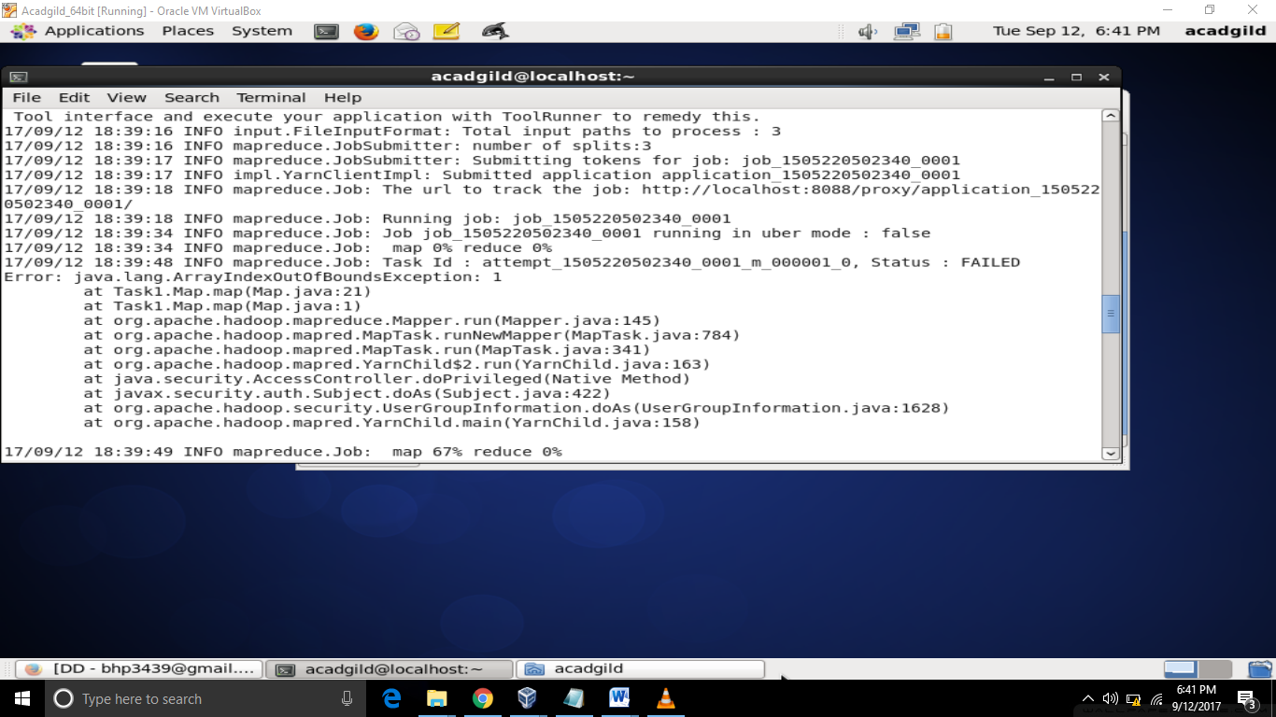

Output:

